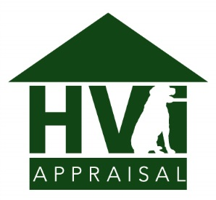
HVI Payment
www.hvipayment.ca

Payment by Visa or MasterCard
In your internet browser, go to www.hvipayment.ca and enter the Order Details as they appear below into the Payment Form, followed by your credit card information in the Payment Details section. After the payment has been processed, you will receive an email with a receipt.

Order Number/ID:

Property Address: Appraiser Name:

Invoice Amount in CAD:

Payment by Email Money Transfer

Send Transfer to

Question / Memo

Answer

Invoice Amount in CAD

Payment by Cash, Bank Draft, or Certified Cheque

Date

Invoice Amount in CAD

Amount Paid

Appraiser Signature

Terms of Service
The fee for the appraisal provided is not contingent upon the final determination of value or closing of a loan. As such, by entering your information on our payment site, you agree to pay the invoice amount, and will not claim a charge back with your credit card company. Furthermore, the party that placed the order is our client, and therefore HVI will take direction only from them. Should you, or another party request a copy of, or have any concerns with the report, you/they must take this up with our client, the party who originally placed the order.

